FILE ENCRYPTING WITH THE GNU PRIVACY GUARD

A) SYMMETRIC (USING ONE KEY):
* Only one key is used for this process and a passphrase is assigned to this key.
* The content of file is encrypted with this key and when to decrypt, it is decrypted with this key again!

EXAMPLE;

1- Create the file will be encrypted:

2- Encrypt the file with ‘--symmetric’ / ‘-c’ option:

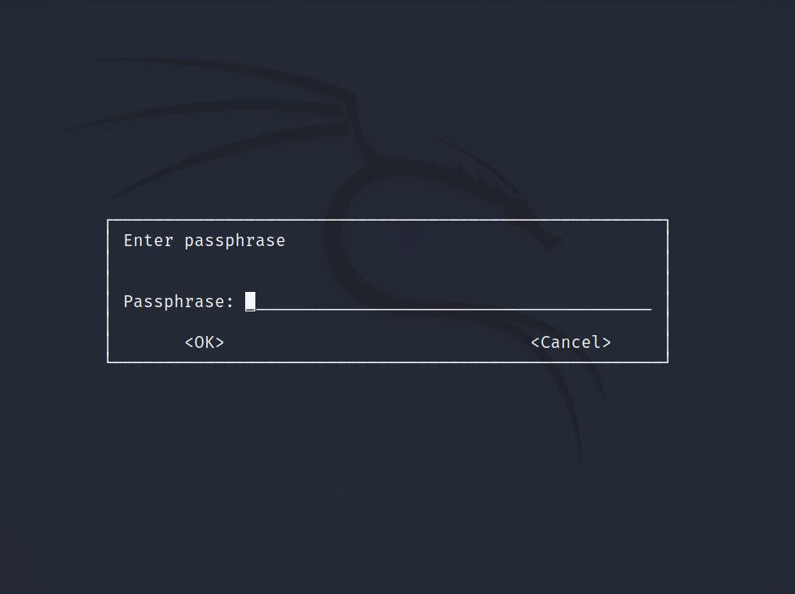
After you entered the command, the system will prompt a passphrase for the key and enter it:

3- List files of the directory that the file is in it:

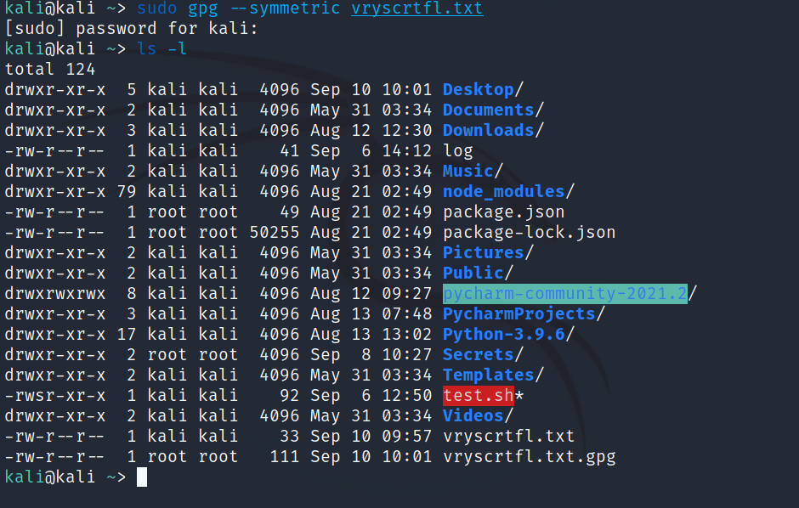

As you can see; there are two vryscrtfl.txt but one of them has also ‘.gpg’ extension! That means this file (vryscrtfl.txt.gpg) was encrypted by the GNU PRIVACY GUARD! So you may want to disappear the original file because of the security, but besides you don’t want to remove it because it can contain very important information! Then instead to remove it with the rm command; you can use shred command which makes disappear that file meaning stamping it with zeros!

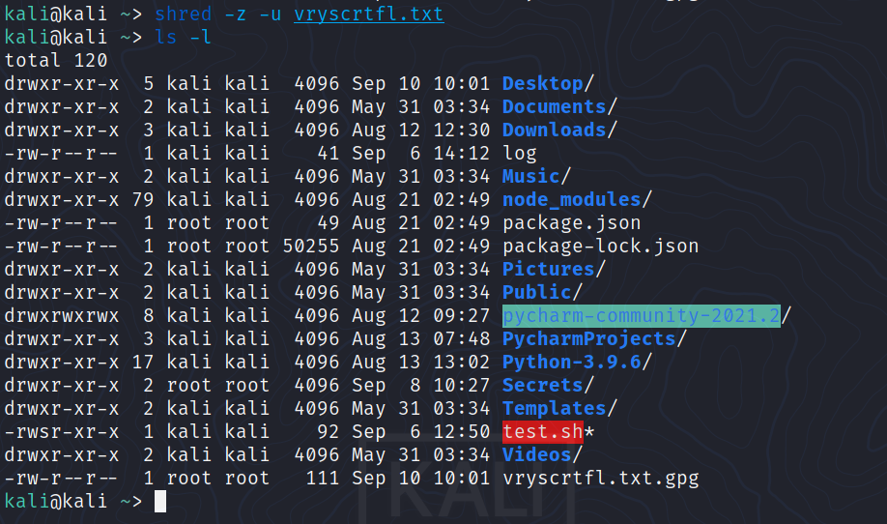
4- Assume that someone gained access to the same pc somehow, he/she need to know the key passphrase to open the file readable. Otherwise even if he/she was able to crack the passphrase somehow, he/she need to know kriptology to decrypt the content that encrypted.

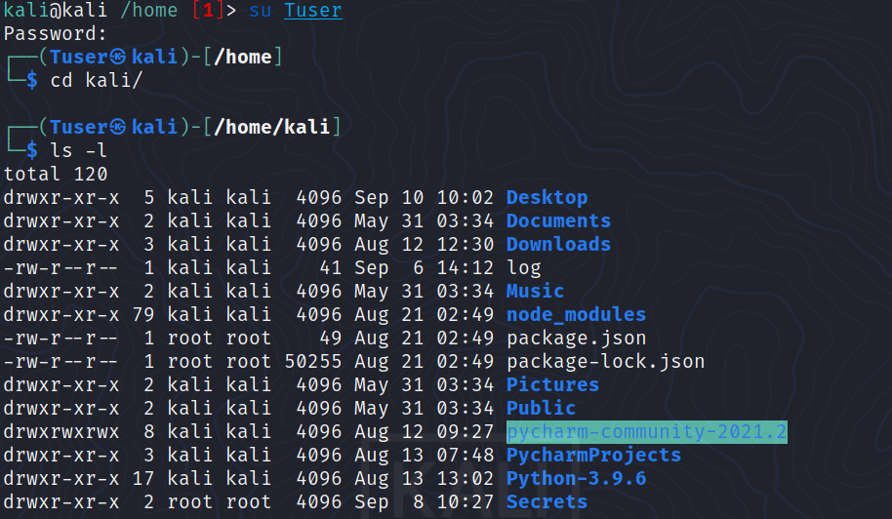
The decryption process is done with -d (decrypt) option!
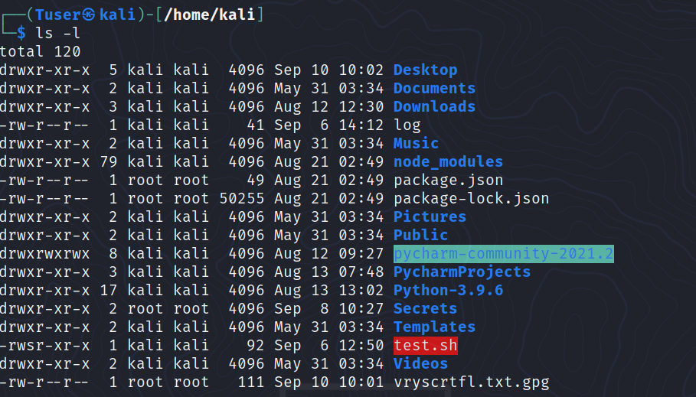
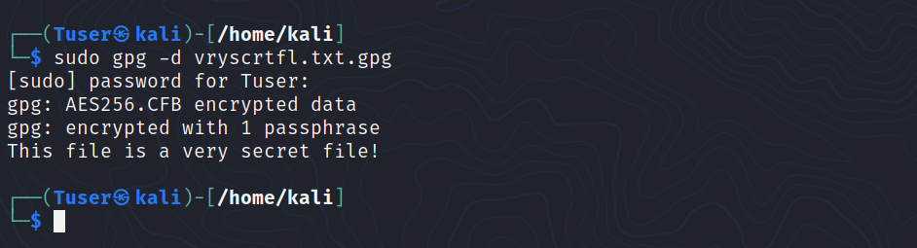
A) ASYMMETRIC CRYPTOGRAPHY (USING TWO RELATED KEYS):
* Also known as ‘Public-Key Cryptography’.
* Is a process that uses a pair of related keys: one public key and one private key.

* A public key is a cryptographic key that can be used by any person to encrypt a message. So that it can only be deciphered by the intended recipient with their private key!
* A private key, also known as ‘secret key’, is shared only with key’s initiator!

*
SITUATION 1: When someone wants to send an encrypted message, they can pull the intended recipient’s public key from a public directory to encrypt the message before sending it. Then the recipient of the message can decrypt the message using their related private key! So the senders use the recipient’s public key to encrypt the message that the senders will send it to them while the recipients use their private keys to decrypt that message.

SITUATION 2: On the other hand; if a sender encrypts the message using their private key, then the message can be decrypted only using that sender's public key (meaning the recipient can only use the sender’s public key for decryption), thus authenticating the sender.

* Many protocols rely on asymmetric cryptography, including the transport layer security (TLS) and secure sockets layer (SSL) protocols, which make HTTPS possible. The encryption process is also used in software programs -- such as browsers -- that need to establish a secure connection over an insecure network like the Internet or need to validate a digital signature.

* Increased data security is the primary benefit of asymmetric cryptography. It is the most secure encryption process because users are never required to reveal or share their private keys, thus decreasing the chances of a cybercriminal discovering a user's private key during transmission.

* How asymmetric cryptography works
Asymmetric encryption uses a mathematically related pair of keys for encryption and decryption: a public key and a private key. If the public key is used for encryption, then the related private key is used for decryption; if the private key is used for encryption, then the related public key is used for decryption.
The two participants in the asymmetric encryption workflow are the sender and the receiver; each has its own pair of public and private keys. First, the sender obtains the receiver's public key. Next, the plaintext -- or ordinary, readable text -- is encrypted by the sender using the receiver's public key; this creates ciphertext. The ciphertext is then sent to the receiver, who decrypts the ciphertext with their private key and returns it to legible plaintext.

Because of the one-way nature of the encryption function, one sender is unable to read the messages of another sender, even though each has the public key of the receiver.

* Uses of asymmetric cryptography
Asymmetric cryptography is typically used to authenticate data using digital signatures. A digital signature is a mathematical technique used to validate the authenticity and integrity of a message, software or digital document. It is the digital equivalent of a handwritten signature or stamped seal.
Based on asymmetric cryptography, digital signatures can provide assurances of evidence to the origin, identity and status of an electronic document, transaction or message, as well as acknowledge informed consent by the signer.
Asymmetric cryptography can also be applied to systems in which many users may need to encrypt and decrypt messages, including:
- Encrypted email - a public key can be used to encrypt a message and a private key can be used to decrypt it.
- The SSL/TSL cryptographic protocols - establishing encrypted links between websites and browsers also makes use of asymmetric encryption.
- Bitcoin and other cryptocurrencies tric cryptography as users have public keys that everyone can see and private keys that are kept secret. Bitcoin uses a cryptographic algorithm to ensure that only the legitimate owners can spend the funds.
In the case of the Bitcoin ledger, each unspent transaction output (UTXO) is typically associated with a public key. So if user X, who has an UTXO associated with his public key, wants to send the money to user Y, user X uses his private key to sign a transaction that spends the UTXO and creates a new UTXO that's associated with user Y's public key.

* Benefits and disadvantages of asymmetric cryptography
The benefits of asymmetric cryptography include:
- the key distribution problem is eliminated because there's no need for exchanging keys.
- security is increased as the private keys don't ever have to be transmitted or revealed to anyone.
- the use of digital signatures is enabled so that a recipient can verify that a message comes from a particular sender.
- it allows for non-repudiation so the sender can't deny sending a message.
Disadvantages include:
- it's a slow process compared to symmetric cryptography, so it's not appropriate for decrypting bulk messages.
- if an individual loses his private key, he can't decrypt the messages he receives.
- since the public keys aren't authenticated, no one really knows if a public key belongs to the person specified. Consequently, users must verify that their public keys belong to them.
- if a hacker identifies a person's private key, the attacker can read all of that individual's messages.

EXAMPLE;

1- Let’s create / generate our own private and public key with the GPG:

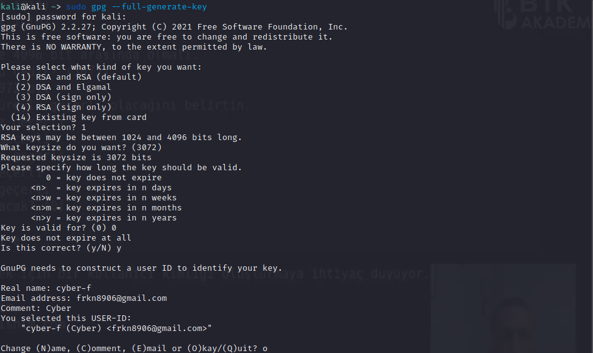

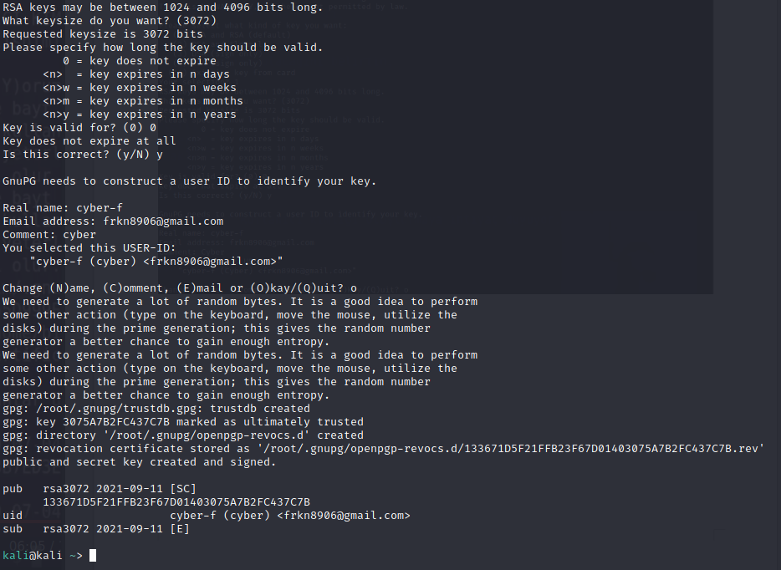

2- to be sure, we can do such as:

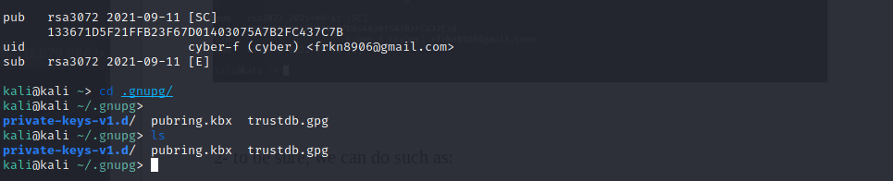

3- create our own public key:

Asymmetric vs. Symmetric Cryptography
The main difference between these two methods of encryption is that asymmetric encryption algorithms makes use of two different but related keys -- one key to encrypt the data and another key to decrypt it -- while symmetric encryption uses the same key to perform both the encryption and decryption functions.
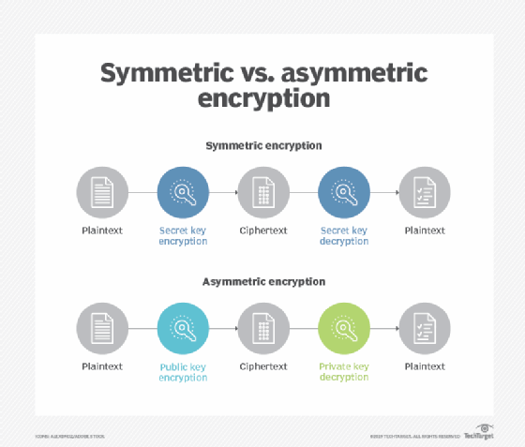

This image displays how the asymmetric cryptography process differs from the symmetric cryptography process
Another difference between asymmetric and symmetric encryption is the length of the keys. In symmetric cryptography, the length of the keys -- which is randomly selected -- are typically set at 128-bits or 256-bits, depending on the level of security that's needed.
However, in asymmetric encryption, there must be a mathematical relationship between the public and private keys. Since hackers can potentially exploit this pattern to crack the encryption, asymmetric keys need to be much longer to offer the same level of security. The difference in the length of the keys is so pronounced that a 2048-bit asymmetric key and a 128-bit symmetric key provide just about an equivalent level of security.
Additionally, asymmetric encryption is slower than symmetric encryption, which has a faster execution speed.

